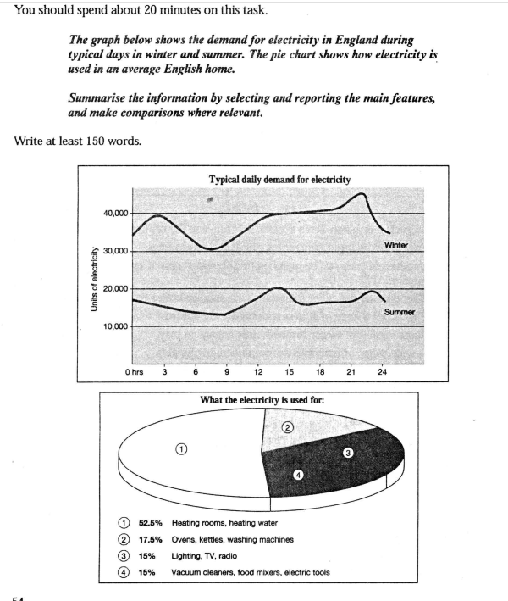

Electricity Usage

The usage of electricity in winter is much more than in summer. Apparently, it is bitterly cold in winter so that many households need heating water. Thus the consumption of electricity increases when the temperature is lower than summer.

The usage of electricity hits the lowest level between 7 a.m. and 8 a.m. during the day both in summer and winter. In winter households tend to consume more power in the afternoon and evening than in the morning and the curve falls dramatically after it reaches the peak at about 10 p.m. The peak of summer is at 2 p.m. and the reason might be that many air conditioners are running. In general, the usage in winter is about two times as in summer.

Heating room and water account for more than 50% of the total power that is used. Ovens, kettles, and washing machines are on the second. Perhaps ovens are the most powerful appliances in the family because they generate heat. Surprisingly, TV, radio and lighting are also account for 15%, maybe they are playing all day.

**improved by Grammarly**

The consumption of electricity is significantly higher in winter than in summer. This is due to the extremely cold weather, which requires households to use heating water. As a result, electricity consumption increases as the temperature drops.

Interestingly, the lowest level of electricity usage occurs between 7 a.m. and 8 a.m. during both summer and winter. However, in winter, households tend to consume more power in the afternoon and evening than in the morning. The usage curve peaks at around 10 p.m. and then falls dramatically. In summer, the peak occurs at 2 p.m., likely because of the increased use of air conditioners. Overall, electricity usage in winter is about twice as high as in summer.

Heating rooms and water account for over 50% of the total power used. Ovens, kettles, and washing machines come in second. Ovens are likely the most powerful appliances in the household because they generate heat.

An Example Answer

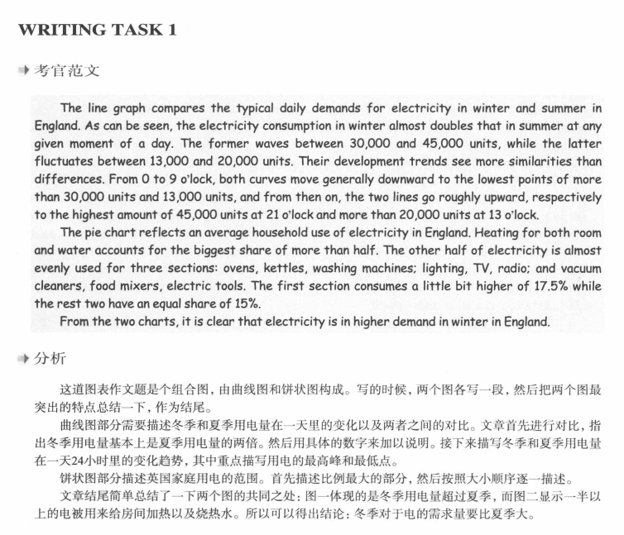

**Grammatical Structures of Pie Charts**

The usage of domestic accomliance is the smallest segment.

Ovens, kettles, washing machines comsume more energy than lighing, or vacuum clearners.

A total of 52.5% is represented by heating rooms and water.

Category H could be the most significant in the future.

The heating systems make up 52.5% of the pie chart.

**Fractions:** The heating systems compromise about one half of the total.

**Proportions:** Over half of the pie chart is taken up by the heating systems.

Linking verbs: While heating for water is the largest, usage of lighting and so on is the smallest.